Image | 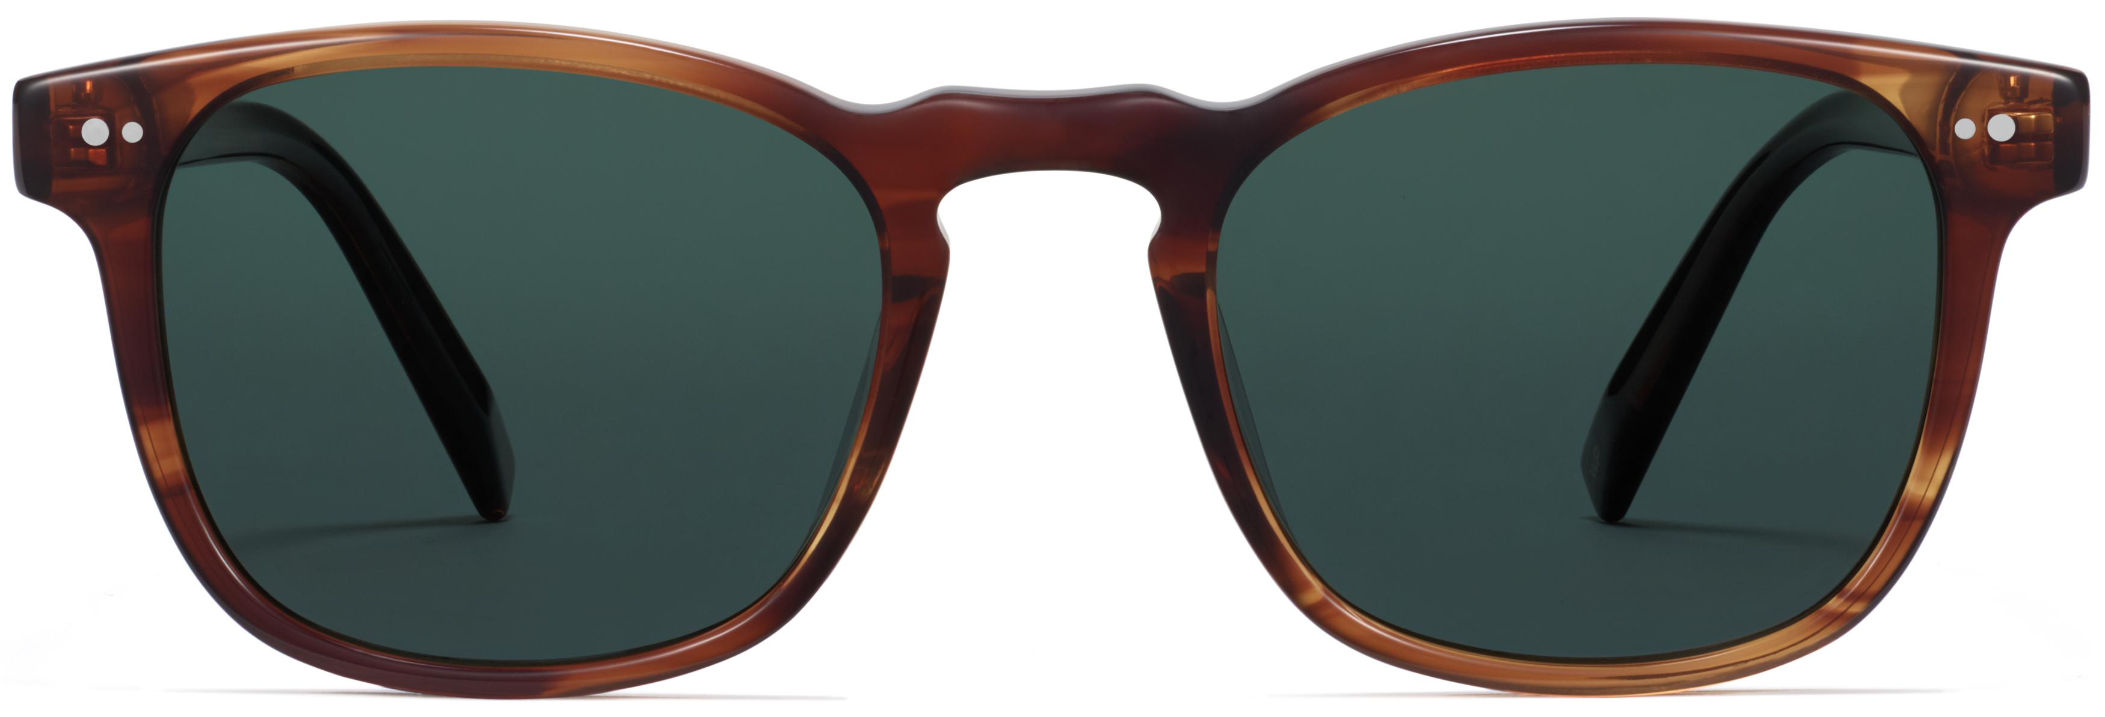
Brand | TOM FORD
Model Name | Elio
Price | RS 9500
PRODUCT DETAILS

